Advance Database Management
FINAL PROJECT ASSIGNMENT

Name: Fazeel Ahmed
Matricola: S5640427
Group: Single Member

Course: ADVANCED DATA MANAGEMENT - 61884
Professor: Barbara Catania and Giovanna Guerrini

Assignment Task 1
- Identify a workload in Natural Language
Q1. Given a player identifier, determine the names of all stadiums in which the player has played at least once. (Player)
Q2. Given a player position and a specified market value, determine the names of all players satisfying those conditions. (Player)
Q3.Given a country name and a competition identifier, determine the types of all game events that occurred in the games of that competition. (Competition)
Q4. Given a player identifier and a specific year, determine all games played by that player during that year. (Game)
Q5. Given a specific year and a player name, determine the player's last season and the total number of minutes played during that year. (Game)
Verification of the Constraints:
Constraints | Result | Relevant queries
At least five structurally different operations | Satisfied | Q1–Q5
Three aggregation entities | Satisfied | (Player , Competition, and Game)
At least three queries selecting on two entities | Satisfied | Q2, Q3, Q4, Q5
At least two paths with length ≥ 2 | Satisfied | Q1 and Q3
Partition-key case (c) | Satisfied | Q4 and Q5
- Use the aggregate-oriented design methodology (STEP 1-2-3) to design a set of logical aggregates for the given domain and the selected workload.
Step 1 (Query Modeling):
Q1:
- E = Player
- LS = [Player(player_id)_!]
- LP = [Stadium(name)_PiPi]

Q1 ( Player, [Player(player_id)_!], [Stadium(name)_PiPi] )

Q2:
- E = Player
- LS = [Player(position)_!, PlayerValuation(market_value)_OF]
- LP = [Player(name)_!]

Q2 ( Player, [ Player(position)_!, PlayerValuation(market_value)_OF], [ Player(name)_! ] )

Q3:
- E = Competition
- LS = [Competition(competition_id)_!, Country(name)_In]
- LP = [GameEvents(type)_OH]

Q3 ( Competition, [ Competition(competition_id)_! , Country(name)_In], [ GameEvents(type)_OH ] )

Q4:
- E = Game
- LS = [Game(date)_!, Player(player_id)_Pi]
- LP = [Game(game_id, season)_!]

Q4 ( Game, [ Game(date)_! , Player(player_id)_Pi ], [ Game(game_id, season)_! ] )

Q5:
- E = Game
- LS = [Game(date)_!, Player(name)_Pi]
- LP = [Player(last_season)_Pi(minutes_played)]

Q5 ( Game, [ Game(date)_!, Player(name)_Pi ], [ Player(last_season)_Pi(minutes_played) ] )
Step 2 (Annotation of the ER Schema):
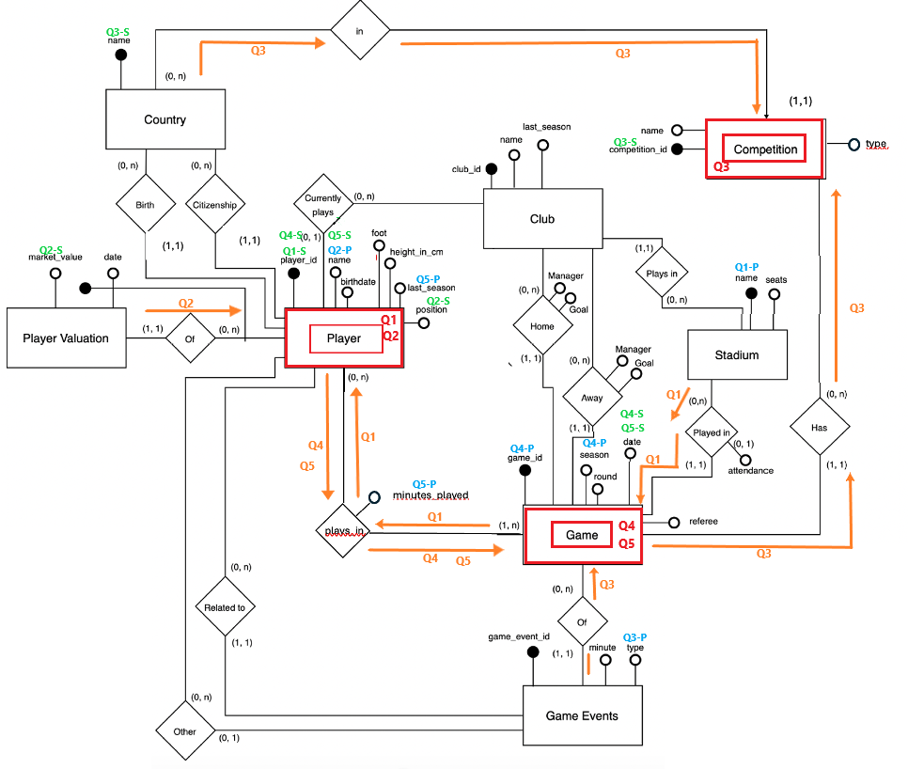
Step 3 (Translation into JSON Meta Notation):
Player Aggregate (Q1 and Q2):
Player =
{
player_id, name, position,
PlaterValuationOF: [ {marketvalue} ],
plays_in:[ {Game: {game_id, name}}]
}

Competition Aggregate (Q3):
Competition =
{
competition_id, country_name,
Games: [ { Game: {game_id, game_event: [ {type} ]} } ]
}

Game Aggregate (Q4 and Q5):
Game =
{
game_id, season, date,
play_by:[ { player_id, name, last_season, minutes_played } ],
}

- For each aggregate-oriented schema and each associated query, specify the query type (either batch or random access query).
- Player Aggregate (Q1 and Q2):
Random access query, because both queries contain selection entities (Player.player_id, Player.position, and PlayerValuation.market_value). Therefore, only a subset of the Player aggregates will be accessed, and no joining with other collections is required.

- Competition Aggregate (Q3)
Random access query (point query), because the query contains selection entities (Competition.competition_id and Country.name). Therefore, only a subset of the Competition aggregates will be accessed, and no joining with other collections is required.

- Game Aggregate (Q4 and Q5)
Random access query, because both queries contain selection entities (Game.date, Player.player_id, and Player.name). Therefore, only a subset of the Game aggregates will be accessed, and no joining with other collections is required.

All queries are Random Access Queries.
- For each designed aggregate-oriented schema, specify a suitable partition key and a suitable super-identifier for the corresponding collection.
- Player Aggregate (Q1 & Q2):
Player = { player_id^{p}, name, position, PlayerValuationOF: [{market_value}], plays_in: [{Game: {game_id, name}}] }
Selection Attributes:
Q1 = {player_id}
Q2 = {position, market_value}
Case: (d) – The two queries do not share any common selection attribute.
Partition Key: player_id
Super-Identifier: player_id
Q1 is favoured because it directly searches a player using player_id. Since player_id is already the identifier and partition key, no extension is required.

- Competition Aggregate (Q3)
Competition = { competition_id^{p1}, country_name^{p2}, Games: [ { Game: {game_id, game_event: [ {type} ]} } ]}

Selection Attribute: Q3 = {competition_id, country_name}
Case: (b) – All queries share the same selection attributes.
Partition Key: (competition_id, country_name)
Super-Identifier: (competition_id, country_name)
The original identifier competition_id is extended with country_name because the super-identifier must include the complete partition key.

- Game Aggregate (Q4 & Q5)
Game = { game_id, season, date^{p}, play_by: [{ player_id, name, last_season, minutes_played }] }
Selection Attributes:
Q4 = {date, player_id}
Q5 = {date, player_name}
Case: (c) – Both queries share the common selection attribute date, but their complete selection sets are different.
Partition Key: date
Super-Identifier: (date, game_id)
The original identifier game_id is extended with date because the super-identifier must include the partition key.
- For each designed aggregate-oriented schema and each associated query, specify if it can be executed efficiently on the collection.
- Player Aggregate (Q1 and Q2):
Q1: Efficient.
The query contains an equality condition on the complete partition key player_id. Therefore, one node is accessed and the required aggregate is directly located.
Q2: Not efficient.
The query selects by position and market_value, but the partition key is player_id. Therefore, the system may need to access all nodes.
- Competition Aggregate (Q3)
Q3: Efficient.
The query contains equality conditions on both partition-key attributes, competition_id and country_name. Therefore, one node is accessed and the required aggregates are sequentially stored.
- Game Aggregate (Q4 and Q5)
Q4: Not fully efficient.
The condition on date identifies one node, but the query also contains a condition on player_id. Therefore, the relevant Game aggregates may not be sequentially stored on that node.
Q5: Not fully efficient.
The condition on date identifies one node, but the query also filters by player_name. Therefore, the relevant aggregates may not be sequentially stored on the node.
- For each designed aggregate-oriented schema, identify the indexes to be created to make the execution of each query associated with the collection efficient (if any).
- Player Aggregate (Q1 and Q2):
A local ordered index must be created on the super-identifier: (player_id)
No additional index is required for Q1 because it selects by the partition key.
To improve Q2, a secondary local index should be created on: (position, market_value)
- Competition Aggregate (Q3)
No additional index is required because Q3 already uses all partition-key attributes and can be executed efficiently.
- Game Aggregate (Q4 and Q5)
A local ordered index must be created on the super-identifier, with the partition key first: (date, game_id)
To improve Q4, create a secondary local index on: (date, player_id)
To improve Q5, create a secondary local index on: (date, player_name)

DISCLOSURE: I used a Large Language Model (LLM) to improve the wording of the natural language queries and to help generate and understand the partition key and super-identifier, as applying the partition key selection cases to the queries was sometimes confusing. The final submission reflects my own understanding after reviewing the lecture material.

